School Site Council Minutes 3/8/2021
Present: Julie Crafton, Molly Gilmartin, Gregg Levin, Gerardo Martinez, Lina Musayev, Kristen Toffer, Kelsey Walsh

Key Takeaways

- Welcome and Agenda Review
Agenda items and meeting norms were reviewed. Council members were invited to share any updates from the community.

- Commissioner of Education Announcement
Late in the afternoon on Friday, March 5, 2021, Commissioner of Education, Jeffery Riley communicated his request that all students K-5 are to return to 5 days a week of in-person instruction. The superintendent has a webinar scheduled for Thursday evening, March 11, 2021. A family survey will go out to assess family interest (both hybrid and RLS).

Principals are working on furniture needs, scheduling, reworking lunch and safety protocols.

- MCAS Testing
New testing window based on return to five day in person learning—May 10th-June 11th. This will be an abbreviated version in ELA, Math, Science and Technology.
- Tentative Schedule--
- May 11 Grade 5 ELA; May 13 Grade 4 ELA; May 14 Grade 3 ELA
- May 25 Grade 5 Math; May 27 Grade 4 Math; May 28 Grade 3 Math
- June 1 Grade 5 Science/Technology

Testing will be an abbreviated version—Math, ELA, Science/Tech
Testing will be live and computer based.
MCAS is designed for school accountability and not to diagnose student learning.

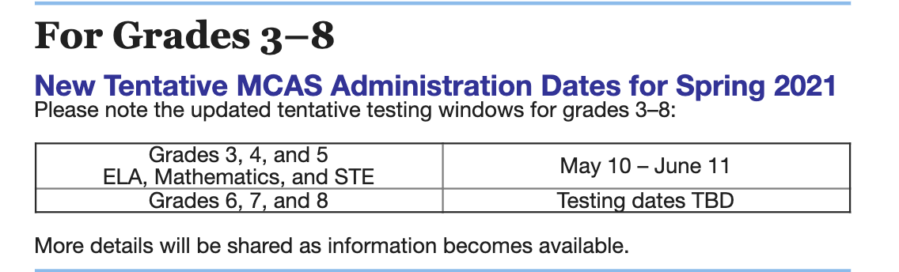

- DEI Update and WMS Letter to Community
- Questions raised for further discussion. How can Diversity, Equity and Inclusion (DE&I) work be more visible beyond the monthly PTO meetings? (Some teachers include DE&I in newsletter. Ex. Langston Hughes poem discussion. Librarian has extended collection of books to include more characters from different cultural backgrounds and themes.)
- Gerardo has worked with all principals to bring access interest in bringing a facilitator to talk to families about ways to engage their children in conversations about racism. PTO moderator, Lisa Collins, has worked with all PTOs to discuss this offering and is collaborating to get this scheduled for some evening in April.
- April 5th-29th is Wellesley’s Racial Equity Habit Building Challenge. The DE&I website says more information is forthcoming.
- BLM Flag: The topic of BLM flags recently placed at the MS and HS was brought up at the PTO Board meeting. Council members read Principal Mark Ito’s letter to his community and shared their thoughts. There was wondering about supporting the MS and HS. Gerardo shared principals would be meeting to discuss further.

Meeting Adjourned at 4:25pm

