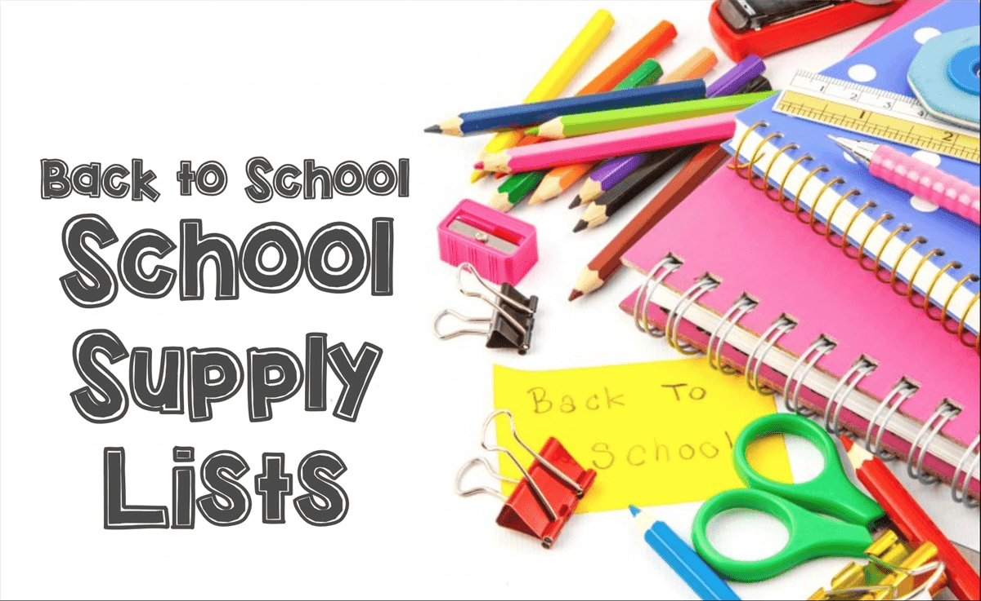 August 4, 2021

Dear Schofield Families,

With Back to School shopping in full swing, the following supplies list by grade will be helpful as you prepare your children for a return to learning in a few weeks.

Kindergarten | 1st Grade | 2nd Grade
Hand Sanitizer  Face Masks (2 Min. Daily)  Crayola Washable Super Tip  Markers  On ear headphones (3.5mm) for ipad  Crayola twistable crayons (set of 24)  Reusable plastic or metal water bottle  Snack and lunch box  Backpack | Face Masks (2 Min. Daily)  Post its, 3”x5”  On ear headphones (3.5mm) for ipad  Package of broad line markers  Pack of Paper Mate Flair Felt-Tip Pens (assorted colors if possible)  Small pack of colored pencils  Box of 24 Crayola crayons  Scissors  Large glue stick  Snack and lunch box  Backpack | Hand Sanitizer  Individual Bin to hold supplies  Face Masks (2 Min. Daily)  On ear headphones (3.5mm) for ipad  Post its, 3”x3”  Non-toxic wipes  Scotch tape  Box of 24 Crayola crayons  Large glue stick  Snack and lunch box  Backpack
3rd Grade | 4th Grade | 5th Grade
Hand Sanitizer  Non-toxic Wipes  Face Masks (2 Min. Daily)  Post its, 3”x3”  Headphones (3.5mm) for ipad  Post its, 3”x5” with lines  Erasable colored pencils  Markers (Washable)  Number 2 pencils  Pack of erasers  Colored pens for editing  Box of 24 Crayons  Scissors  Glue sticks  Snack and lunch box  Backpack | Hand Sanitizer  Face Masks (2 Min. Daily)  Headphones (3.5mm) for ipad  Post its, 3”x3  Headphones (3.5mm) for ipad  2 Packages of number 2 pencils  Felt-Tip Pens  2 Scotch tape  1 Box of 24 Crayola crayons  1 Scissors  2 glue sticks  1 set of color pens  1 set of markers  Pack of erasers  1 stylist of iPad  Snack and lunch box  Backpack | Hand Sanitizer  Face Masks (2 Min. Daily)  Post its, 3”x3”  Headphones (3.5mm) for ipad  4 single subject spiral notebooks  Package of number 2 pencils  12 Pack of Paper Mate Flair Felt-Tip Pens  Glue Stick  Box of 24 Crayola crayons  Pack of markers  Scotch tape  Ruler  Scissors  Snack and lunch box  Backpack

