Schofield School

Go Hawks!

September 6, 2021
Dear Schofield Families,

What a wonderful first week of school! Your children were thrilled to reunite with friends and to get to know their teachers and new classmates. The weather was perfect and we got to have snack and lunch outdoors. We are grateful to be back with your children and to plan for their academic and social growth this year.

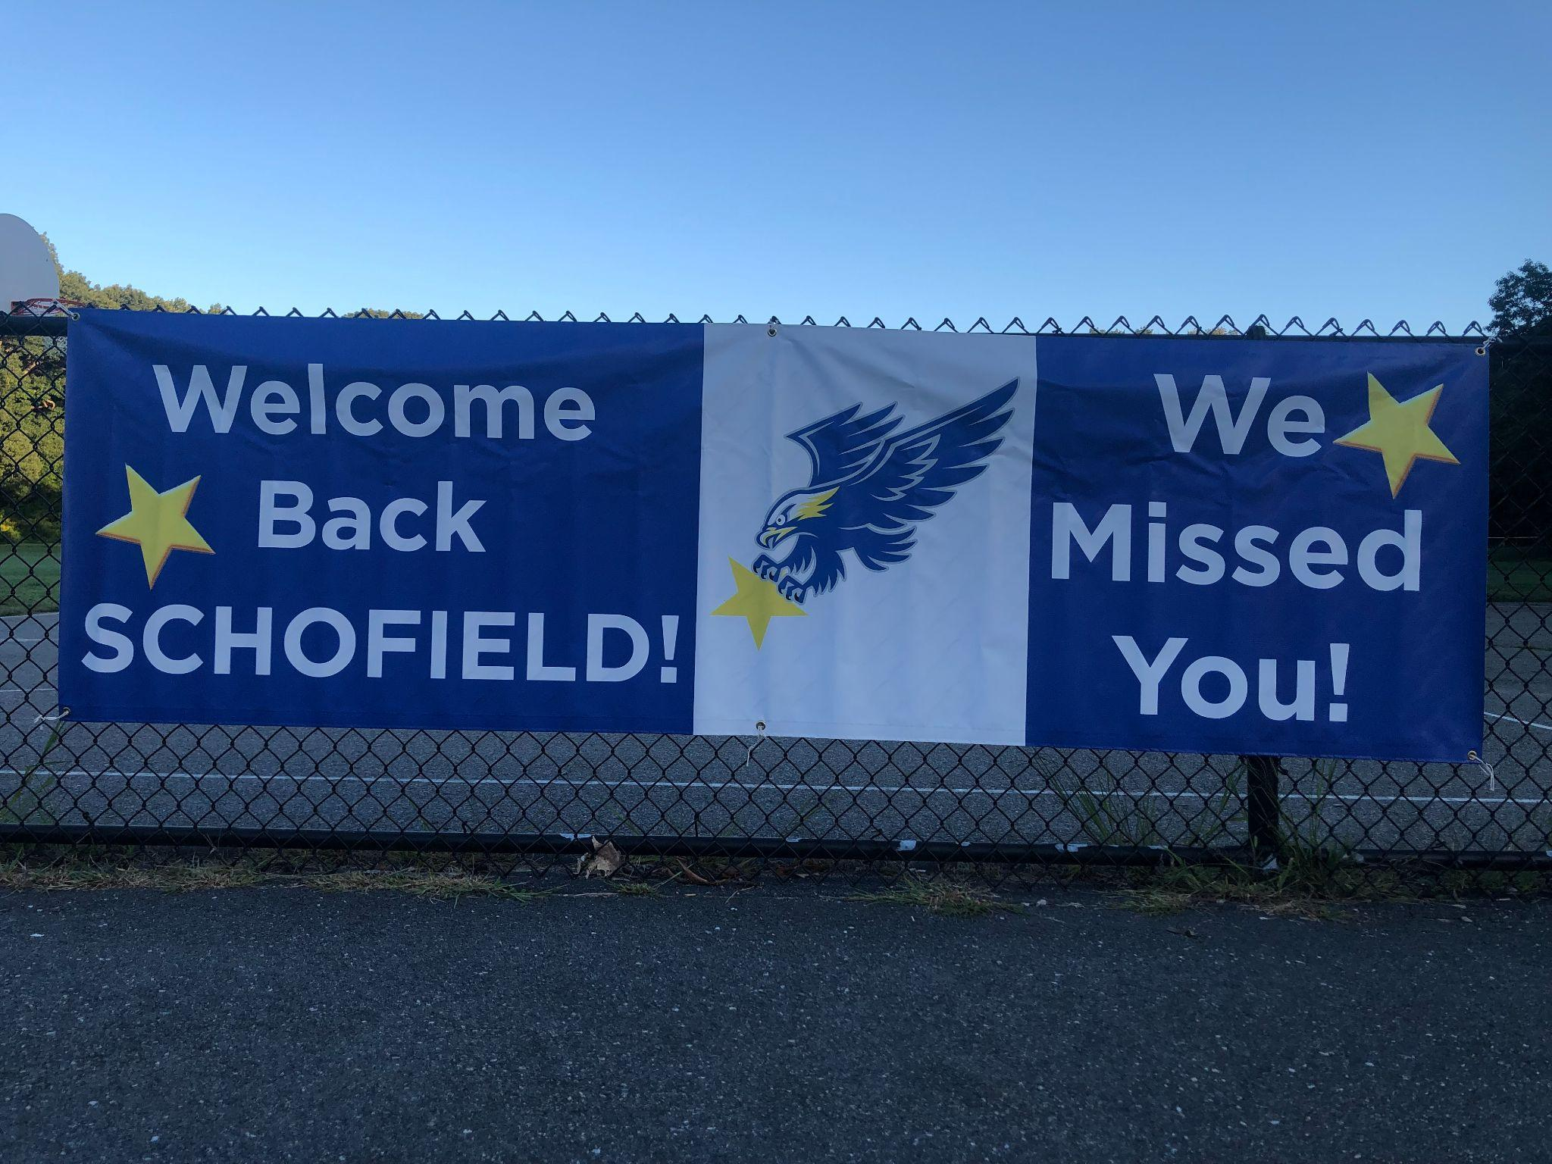

Below is a glimpse at next week’s calendar and a few FYIs. Enjoy the four (4) day weekend! If you celebrate the Jewish New Year--l'shana tova!

Warmly,
G

Monday  September 6, 2021  No School  Labor Day | Tuesday  September 7, 2021  No School  Rosh Hashanah | Wednesday  September 8, 2021  Noon Dismissal Every Wednesday  Faculty Meeting, 1:00-2:00 pm | Thursday  September 9, 2021  Full Day, 3:05 Dismissal for Grades 1-5  Kindergarten Noon Dismissal  Schofield Family Picnic, 5:00-7:00p pm | Friday  September 10, 2021  PTO Check in  Flag Raising Live Streaming with Kindergarten Outside 9am  Full Day, 3:05 Dismissal for Grades 1-5  Kindergarten Noon Dismissal

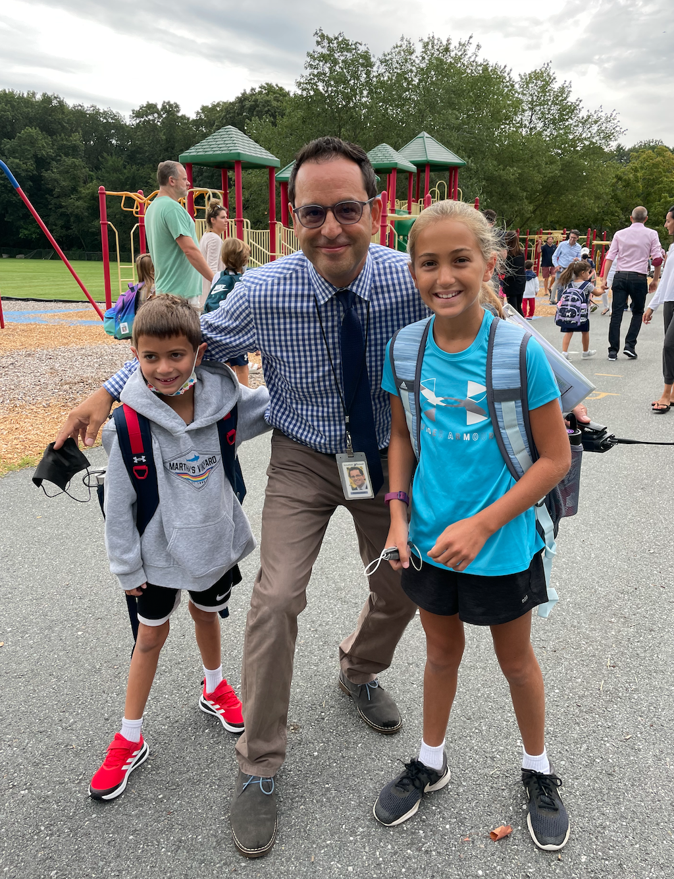
Day One Jitters: We got through the first few days. Knowing where to go and where to stand and how to enter the building is always the toughest initial experience and lesson of the school year. We did it though!!!! Here is a plug from one of our parents, Elizabeth Kaplan, who supports the production of our annual year book. Please share any first day of school pictures to kick off the yearbook work. We would be so appreciative! You can email pics to schofieldyearbook22@gmail.com

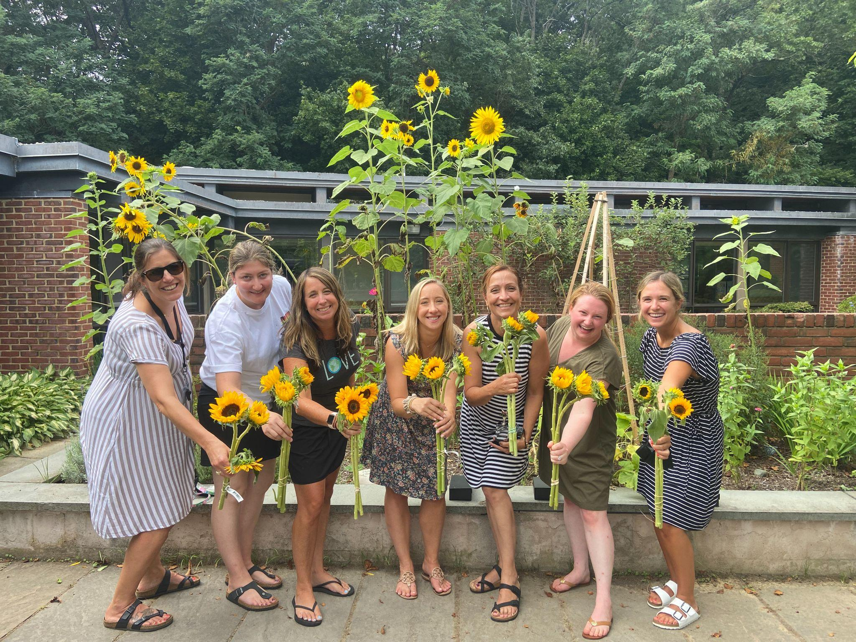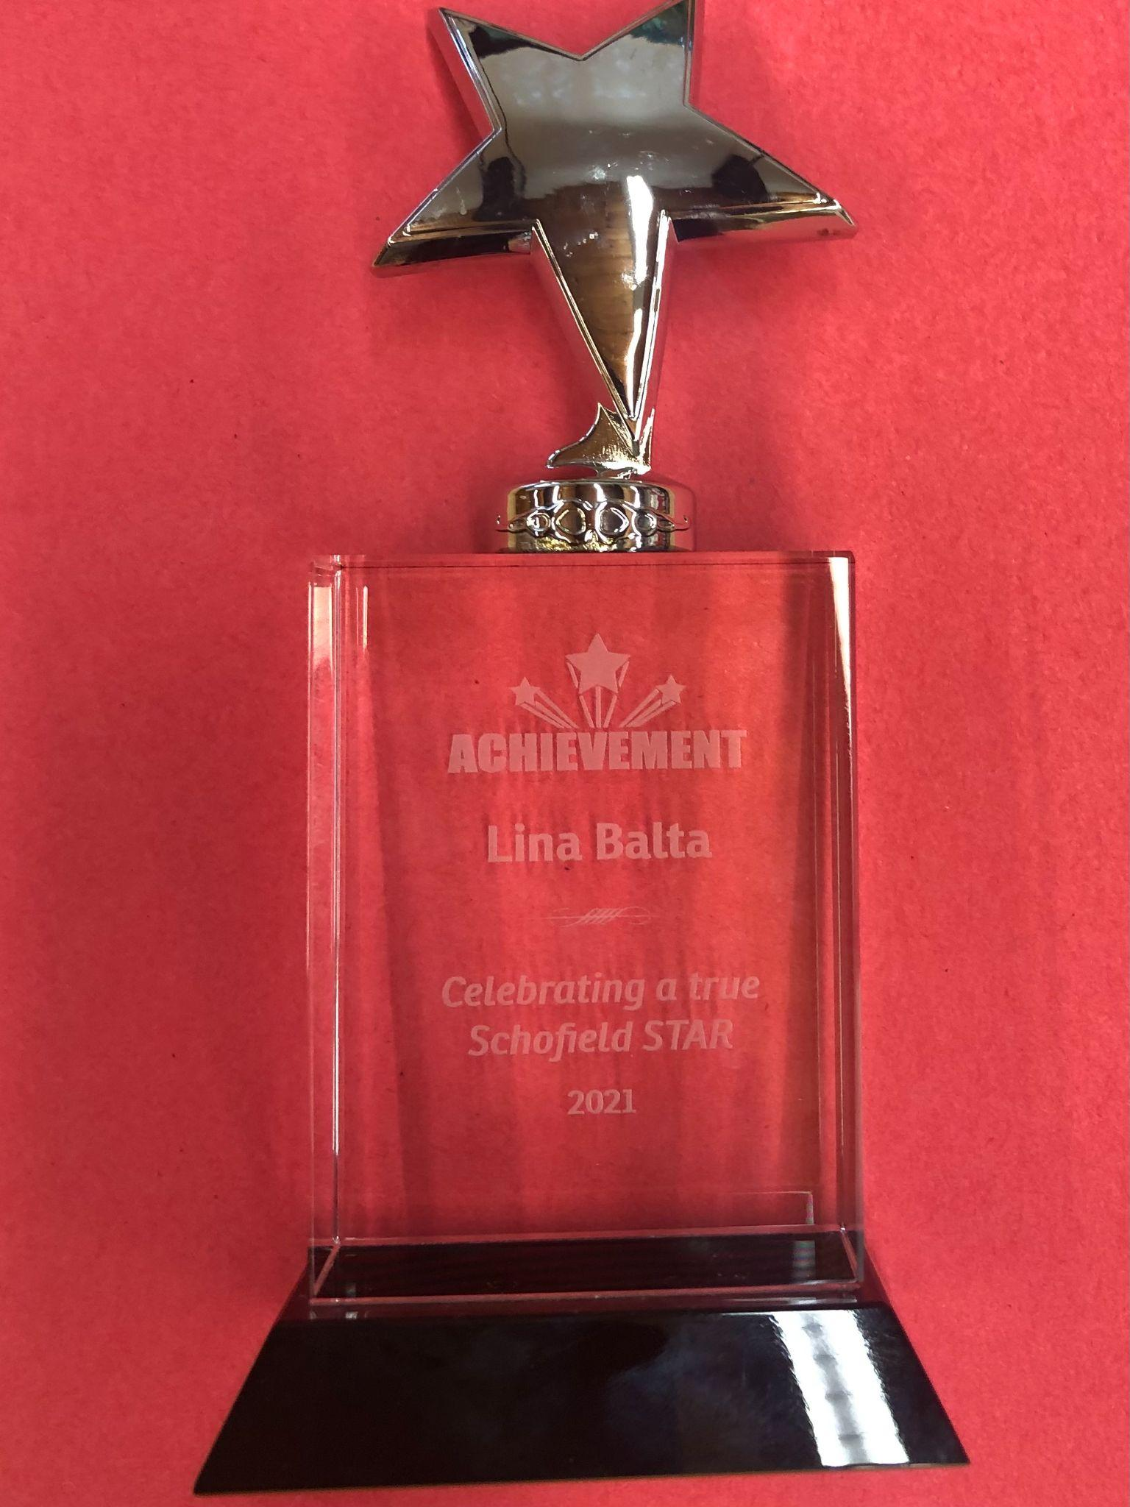
Honoring Our Teachers: Each year we honor teachers who are starting year four of their career. It’s a time when their craft has been highly refined and they shine brighter than they did when they commenced their professional career. This year we honored the following. From left to right in the photo above: Kate Wilson, English Language Learner (ELL) Teacher; Amanda El-Lakkis, grade 4; Joanna Doyle, grade 5; Emily Paterson, grade 2; Ruth Ortiz-Collazo, Spanish teacher; Kelsey Walsh, special educator; Lina Balta, grade 3. We had a lovely lunch, provided flowers and presented each teacher with a STAR trophy. We are so lucky to have these amazing teachers!

Infinity Math Squad: For the past few years we have had the opportunity for students, grades 2-5 to participate in a free math tutoring program that links them to Wellesley High School student volunteers. We will be opening up Infinity Squad applications on 9/20 so bookmark the following link so that you can sign up your child in a few weeks. It will be virtual again this year, 30 min per week and running from October and through April break.
Here is the link (https://forms.gle/B69mEGsmS7WfuFjd7).

Temple Parking Our neighbors at Temple Beth Elohim have changed their car line routines. This year, it will be in the front of the building, which means that the entire parking lot will be used to stage cars waiting to be dropped off/picked up. Drop-off runs from 8:15 am to 9:15 am on a rolling schedule, and pickup will be at 1:00pm. Therefore, we want to remind the community to not use the temple lot. Be aware that the gate will be locked so walking across will be prohibited.

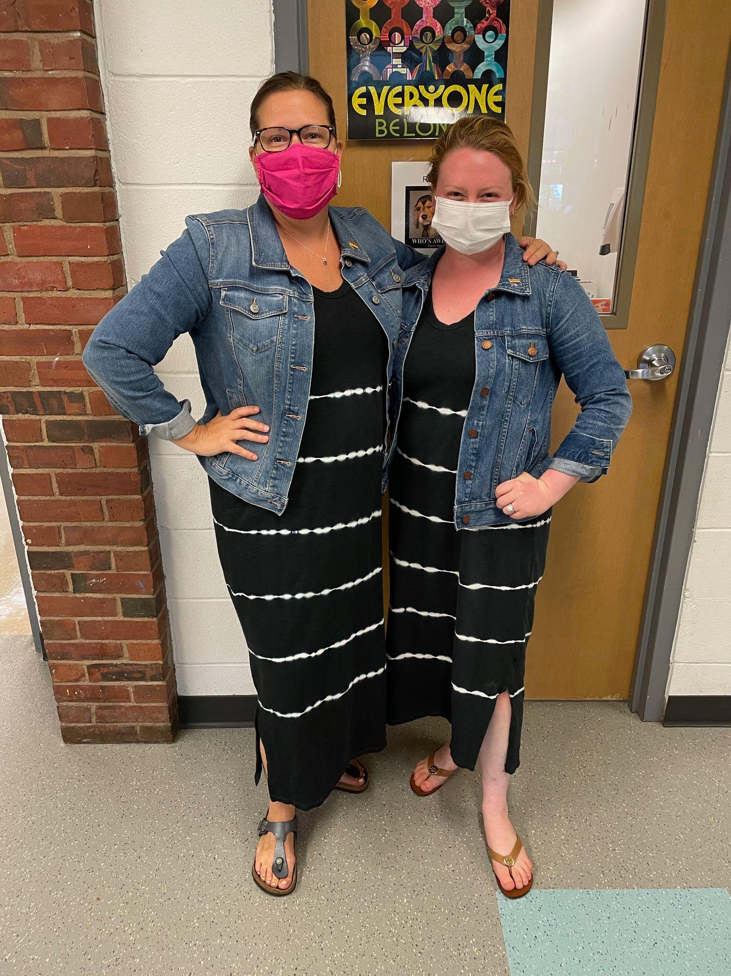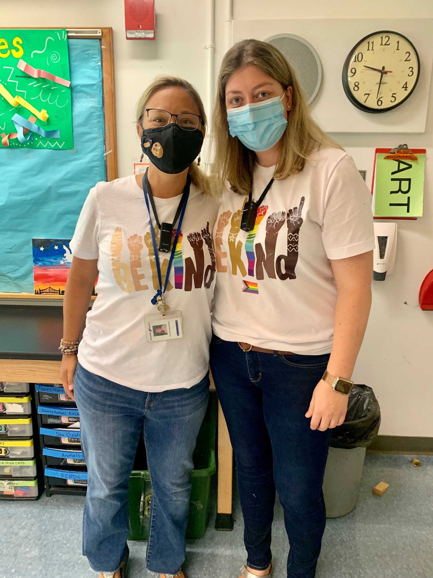
First Twinning Sighting: Could these be the first 2021-2022 twinning sightings? There is no need to ask who wore it better and they all look marvelous!!

Poem of the Week:

Reflection
by Rabindranath Tagore (1861-1941)

Keep me fully glad with nothing. Only take my
hand in your hand.
In the gloom of the deepening night take up my
heart and play with it as you wish. Bind me close to you
with nothing.
I will spread myself out at your feet and lie still.
Under this clouded sky I will meet silence with silence.
I will become one with the night clasping the earth in
my breast.
Make my life glad with nothing.
The rains sweep the sky from end to end. Jasmines
in the wet untamable wind revel in their own perfume.
The cloud hidden stars thrill in secret. Let me fill to
the full my heart with nothing but my own depth of joy.

